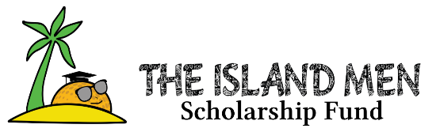


2026 Island Men Bourbon Raffle Winners
Congratulations & thank you for supporting
The Island Men Scholarship Fund
To see what was in each lot https://theislandmen.com/event/bourbon/

Lot #1: Jim Mushfen
Lot #2: Andrew Finnegan
Lot #3: Tyler Ashbridge
Lot #4: Fran Murphy
Lot #5: Barbara Ray
Lot #6: Garret Dunlap
Lot #7: Gilbert DuBois
Lot #8: Garrett Wendell
Lot #9: Jim Scandra
Lot #10: Russ Herman
Lot #11: Phillip Swack
Lot #12: Christian Bourgeois
Lot #13: Dan Day
Lot #14: Jimmy Gartland
Lot #15: Ed Langville
Lot #16: Gary Coleman
Lot #17: Cathrine Robbins
Lot #18: Shawn Emmons
Lot #19: Jeff McLaughlin
Lot #20: Rick Paxton
Lot #21: John Powers
Lot #22: Kelsey Shackelford
Lot #23: Mitch Jackson
Lot #24: Ed Langville
Lot #25: Tony Borrello

